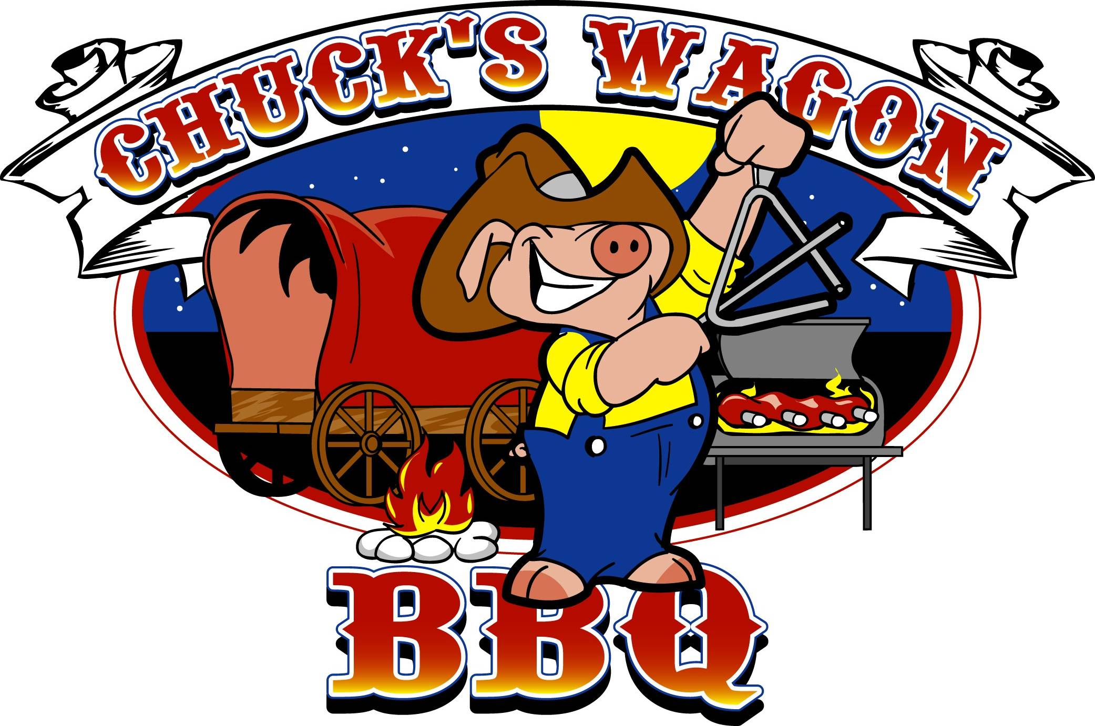
Party Packs

Our party packs are perfect for gatherings of 10 to 100! All orders must be placed 48 hours in advanced. A 50% non-refundable deposit is due at the time of the order.

All party packs come with baked beans, coleslaw, bbq sauce and buns.

Choose from Pulled Pork, Smoked Chicken, Ribs, or Beef Brisket.
One Meat / 11.99
Two Meat / 13.99
Three Meats / 15.99

Ordering
For carry or catering orders, call
(301) 262-1546

Mon – Thurs: 11 am – 9 pm
Fri-Sat: 11 am – 9 pm
Sun: 11 am – 8 pm
Email: chuckswagonbbq@yahoo.com

www.cwbbq.com

At Chuck’s Wagon BBQ, ‘We don’t sauce our ribs, because we don’t have anything to hide’. Over the course of time, we have worked very hard to develop and perfect our signature rubs to enhance the natural flavoring of our meats. We smoke all of our meats daily so you are always guaranteed the very best we have to offer.

Instead of trying the rest, isn’t it time you tried the best? Find out why Chuck’s Wagon BBQ was so highly favored in the Washington Post and voted Best BBQ in Prince George’s County Maryland. Let us be the ones to deliver the perfect BBQ right to your table. We have been serving District, Maryland and Virginia residents for many years. To make your next event a success, call Chuck’s Wagon BBQ!
6946 Laurel Bowie Road, Bowie, MD 20715

(301) 262-1546

www.cwbbq.com
Take Out Menu
If you can’t smell the smoke, it ain’t real bbq

Sandwiches

*All sandwiches come with coleslaw*

Pulled Pork / 6.99
North Carolina Style w/ a hint of heat

Pulled Chicken / 6.99
Seasoned with our original bbq sauce

Ribs / 7.99
3 bones of our juicy ribs served with white bread

Beef Brisket / 8.99
Juicy sliced brisket – served with extra juice upon request

Rib Tip / 6.99
Bone in rib chunks smothered in our original bbq sauce – served with white bread

Fried Fish / 7.49
Fried Whiting served on white bread

CatFish / 8.99
Catfish served on white bread

Platters and Combos

*All dinners are served with two sides and cornbread*

One Meat 11.99
Two Meats 14.99
Add A Meat 3.99

Ribs • Pulled Pork• Beef Brisket
Smoked Chicken (1/4 dark meat)
Fried Fish Dinner - 11.99**
CatFish Dinner – 12.99** Rib Tip Dinner - 10.99**
**served with white bread – substitute cornbread - .50

Sides

Potato Salad, Baked Beans, Greens, String Beans, Macaroni and Cheese, Coleslaw, Cabbage, Yams, Fried Okra, Hushpuppies, Fried Zucchini Sticks

Small / 3.99
Medium / 5.99
Large / 9.99

French Fries / 2.99

Drinks

Medium / 1.65
Large / 1.85

Dessert
(Varies depending on mood)

Mini Sweet Potato Pie / 2.79
Cobbler / 3.99
(peach, pear)

By the Pound

Pulled Pork / 13.99 per lb
Pulled Chicken / 13.99 per lb
Beef Brisket / 17.99 per lb
Ribs – 24.00 per rack
½ rack 18.00

Wings
(plain, hot, bbq or Mombo)

5 pc / 6.99
10 pc / 9.99
15 pc / 14.99
20 pc / 19.99

